DAY 5

1)Install Maven

Command: sudo apt update  
 sudo apt install maven -y  
 To Check Version: mvn -version

2)Pipeline Script  
pipeline {

agent any

environment {

DOCKER_IMAGE = "nirajana23/devops"

DOCKER_TAG = "latest"

DOCKER_CREDENTIALS_ID = "9dae9d83-68b8-431b-945f-b6f3cde4ab04"

KUBECONFIG = "/var/lib/jenkins/.kube/config"

}

stages {

stage('Checkout Code') {

steps {

git url: 'https://github.com/Nirajana-Selvaraj/day5devops.git', branch: 'main'

}

}

stage('Build Application') {

steps {

script {try {

sh '${MAVEN_HOME}/bin/mvn clean package -DskipTests'

} catch (Exception e) {

sh 'mvn test -Dmaven.test.failure.ignore=true'

echo "Tests failed, but proceeding..."

}

}

}

}

stage('Run Maven Tests') {

steps {

script {

try {

sh 'mvn test'

} catch (Exception e) {

sh 'mvn test -Dmaven.test.failure.ignore=true'

echo "Tests failed, but proceeding..."

}

}

}

}

stage('Build Docker Image') {

steps {

echo "Building Docker image..."

sh 'chmod +x build.sh'

sh './build.sh'

}

}

stage('Login to Docker Hub') {

steps {

echo "Logging into Docker Hub..."

withCredentials([usernamePassword(credentialsId: '9dae9d83-68b8-431b-945f-b6f3cde4ab04', usernameVariable: 'DOCKER_USER', passwordVariable: 'DOCKER_PASS')]) {

sh 'docker login -u $DOCKER_USER -p $DOCKER_PASS'

}

}

}

stage('Push Docker Image') {

steps {

echo "Pushing Docker image to Docker Hub..."

sh "docker tag $DOCKER_IMAGE:$DOCKER_TAG $DOCKER_IMAGE:$DOCKER_TAG"

sh "docker push $DOCKER_IMAGE:$DOCKER_TAG"

}

}

stage('Deploy Docker Container') {

steps {

echo "Deploying Docker container..."

sh 'chmod +x deploy.sh'

sh './deploy.sh'

}

}

}

post {

success {

echo "Deployment Successful!"

}

failure {

echo "Deployment Failed!"

}

}

}

3)Build a new pipeline job  
 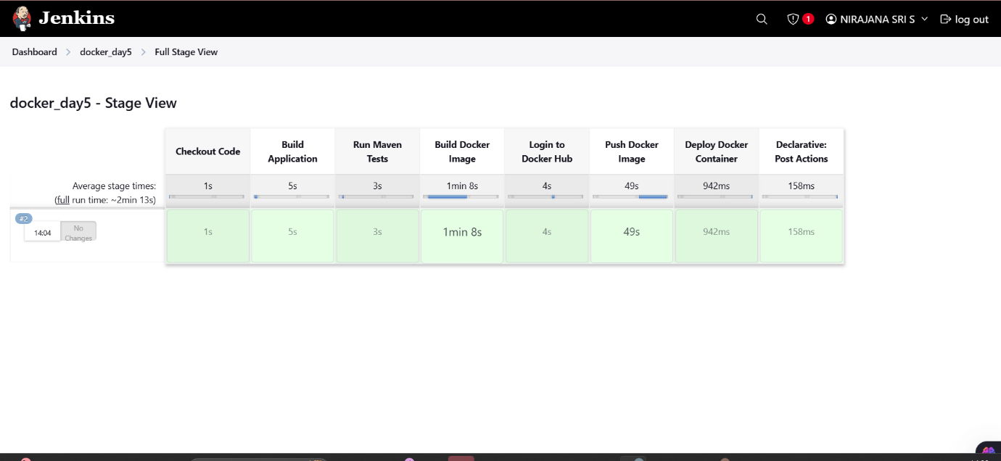

4)Console Output of the pipeline  
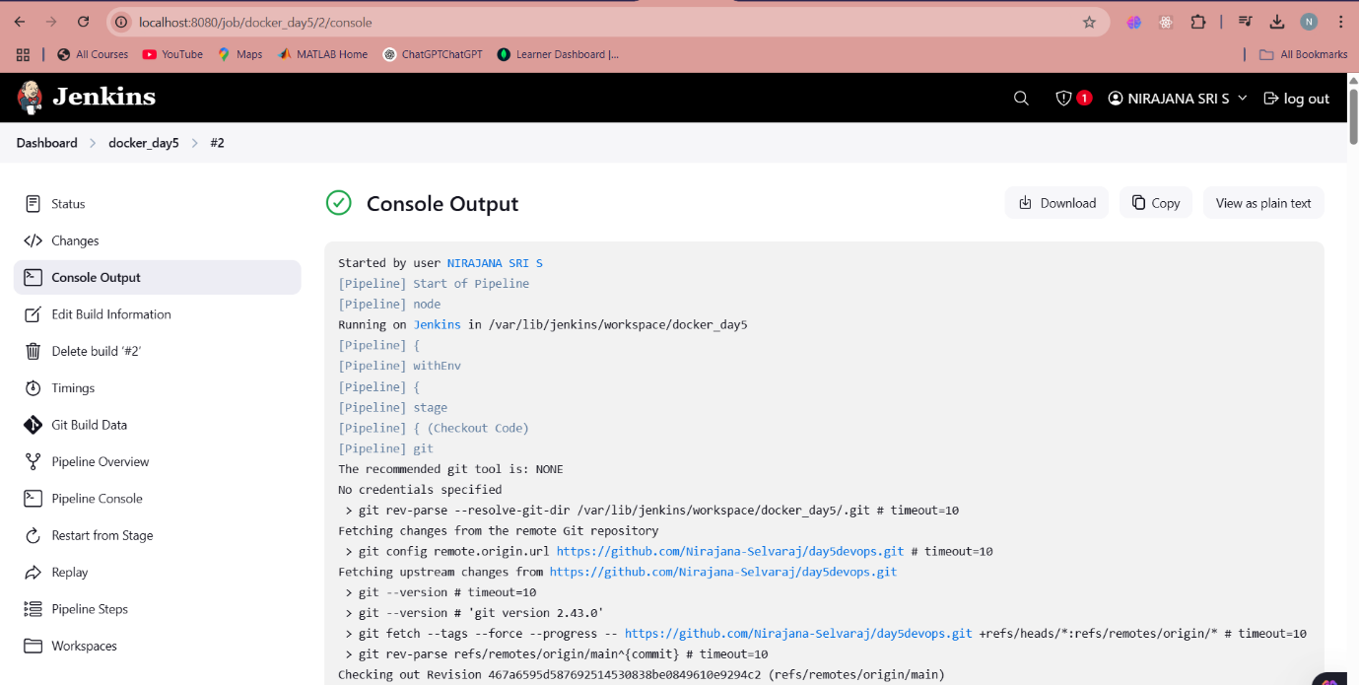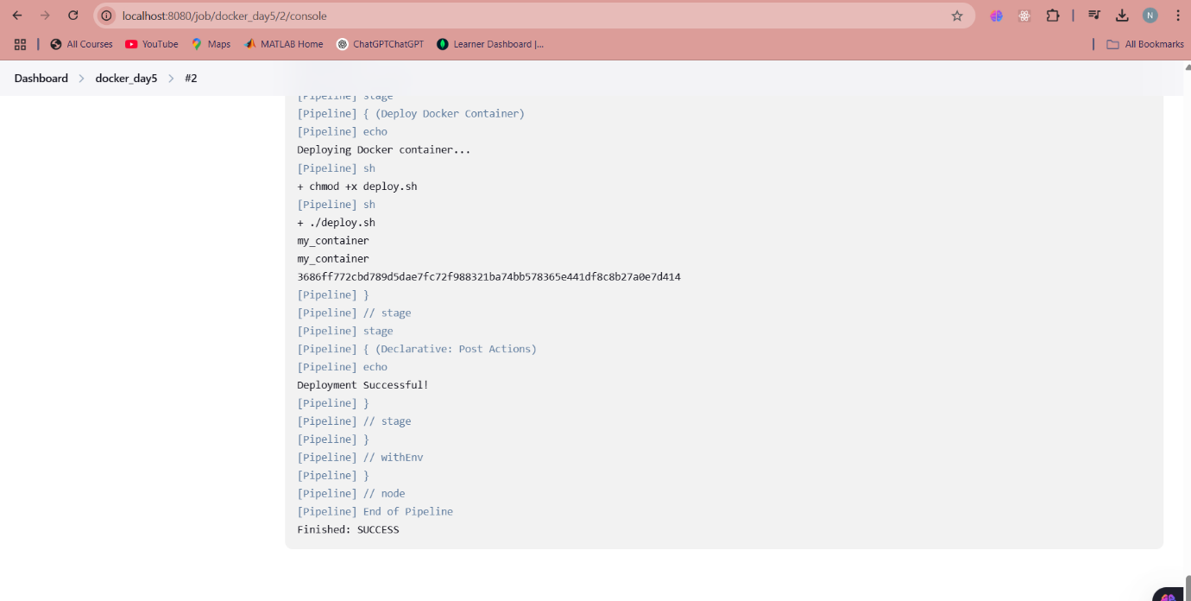

5)Status of the pipeline  
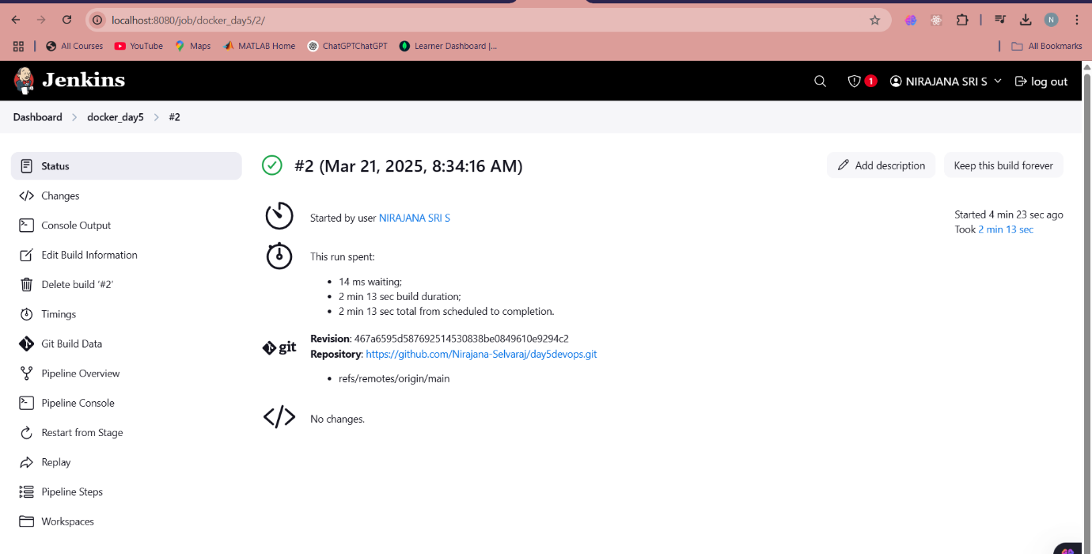

6)Pull docker image  
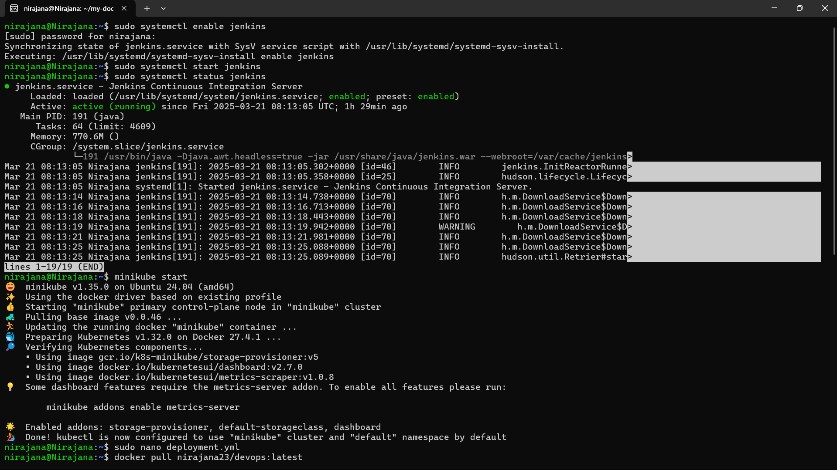

7)Build docker image  
